1. Key concept 5
2. Applies to 5
3. Author & contributors 5
4. Brief Bio about the author 6
5. Business Case/Executive summary 6
6. Target Audience 6
7. Important terminology and abbreviations 7
8. Content 7
9. Design 10
10 Output Files Generated by AI Assisted Application Development Using Joule 16
11. Conclusion 20
12. FAQ Link 20
13. References 20

1. Key concept
This paper aims to showcase the practical example of an AI-assisted application development approach using Joule within SAP Build Code, focusing on rapid data modelling and user interface creation. The application demonstrates how a simple data model consisting of two entities can be efficiently designed using Core Data Services (CDS), forming the foundation for structured data management. Leveraging Joule’s generative AI capabilities, the development process was significantly accelerated, with automated assistance in creating both the data model and the UI components.
An SAP Fiori List Report template was utilized to build the frontend, enabling a responsive and standardized interface with built-in functionalities such as data display, filtering, and sorting, all driven by metadata and annotations. This highlights SAP’s model-driven development paradigm, where the UI is directly derived from backend definitions without requiring extensive manual coding. The project illustrates how AI-powered tools can simplify and speed up the creation of functional, data-driven applications within a low-code/pro-code environment.

2. Applies to
This document is applicable for SAP practitioners to understand and implement AI-driven application development using Joule (Build Code) in SAP environments. It provides guidance on leveraging AI assistance to create custom applications through automated generation of data models, services, and user interfaces. It is applicable to low-code/pro-code development scenarios focusing on metadata-driven application design within the SAP ecosystem.

3. Brief Bio about the author

Ganesh Krishnasingh is a strategic Delivery Architect with proven expertise in leading complex SAP transformation programs and delivering innovative SAP S/4HANA and SAP BTP solutions. As the Development and Integration Lead for a large-scale S/4HANA transformation initiative, he currently oversees a team of 52+ consultants, driving architecture, development, integration, and governance across multiple workstreams. His leadership in implementing Clean Core, cloud-first, and Fiori-centric strategies has been instrumental in accelerating delivery, enhancing system scalability, and enabling sustainable business transformation. Ganesh consistently demonstrates exceptional technical leadership, people development, client engagement, and execution excellence, making him a strong candidate for advancement to the next leadership level.

5. Business Case/Executive summary

The requirement is to build a custom application to store and manage employee and company data in a structured format and make it available for reporting and management purposes. In traditional development, creating such applications requires manual effort to build database tables, services, and UI, which becomes time-consuming and complex, especially when dealing with structured and related data.

The solution provided is to use Joule (Build Code) to generate the complete application through prompts. The data model for Employee and Company is created using CDS, and the corresponding database tables and OData services are generated automatically. A Fiori Elements List Report application is also created to display and manage the data. This approach ensures efficient handling of structured data, faster development, and enables easy access through a secure OData service.

6. Target Audience
SAP beginners and technical consultants, especially those working as Fiori (UI5) developers, who want to understand and implement AI-driven application development using Joule (Build Code). This document helps in learning how artificial intelligence can be leveraged to generate data models, services, and UI components automatically, enabling faster and more efficient development.

7. Important terminology and abbreviations
Abbreviations | Descriptions
SAP | Systems Application Products in Data processing
Joule | (Artificial Intelligence) AI-powered assistant used for building applications using natural language in SAP Build Code.
Build Code | SAP environment used for developing full-stack applications with AI assistance.
CDS | (Core Data Services) Data modelling framework used to define entities and relationships.
OData | (Open Data Protocol) Standard protocol used to expose and consume data via services.

8. Content

This whitepaper provides a practical illustration of how a simple data-driven application can be developed using SAP Build Code with Joule, enabling rapid creation of data models and user interfaces with minimal manual coding effort. The solution demonstrates how, through natural language prompts, Joule assists in generating core application artifacts such as CDS-based data models and an SAP Fiori Elements List Report application. This includes the automated creation of underlying database tables and a metadata-driven UI that allows users to view, filter, and manage data efficiently.

The application highlights SAP’s model-driven development approach, where the user interface is directly derived from the data model using annotations, eliminating the need for extensive frontend development. While the scope does not include custom backend logic, integrations, or advanced business processing, it effectively showcases how Joule can streamline foundational application development tasks.

By leveraging Joule, the solution enables rapid prototyping, ensures consistency in application design, and significantly reduces development effort. It demonstrates how AI-assisted tools can simplify the creation of functional, data-centric applications within a low-code/pro-code environment in the SAP ecosystem.

8.1 Prerequisites
• Access to SAP Build Code environment.
• Availability of Joule (SAP AI Copilot) for prompt-based development.
• Basic understanding of SAP Fiori (UI5) applications.
• Knowledge of CDS data modelling concepts.
• Authenticated user access for service execution.

8.2 Configuration Requirements
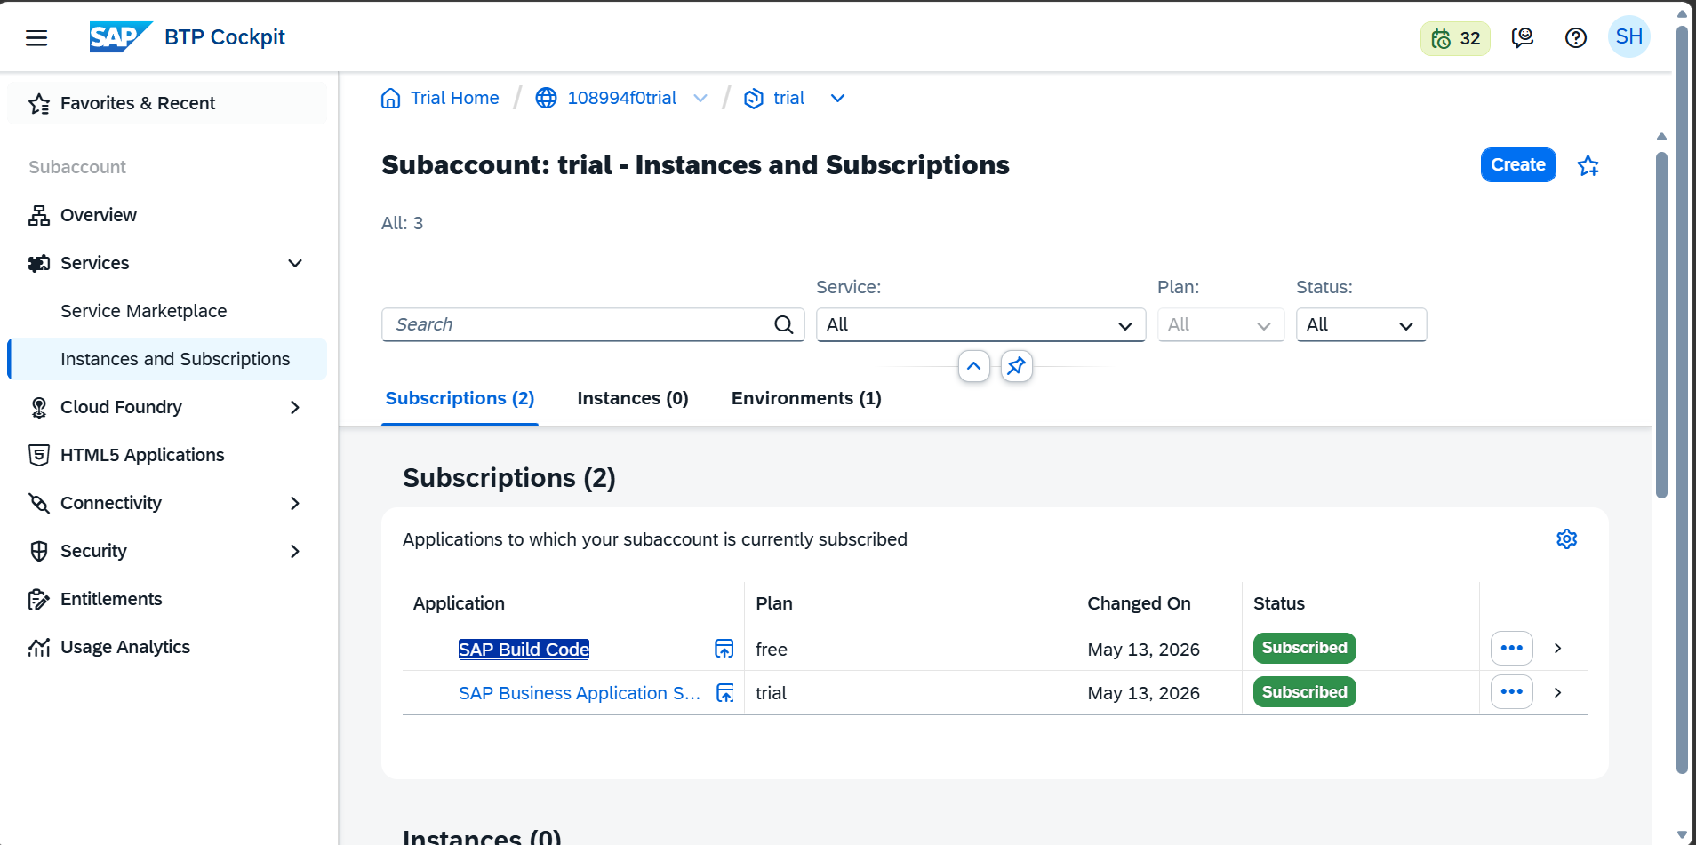

9. Design
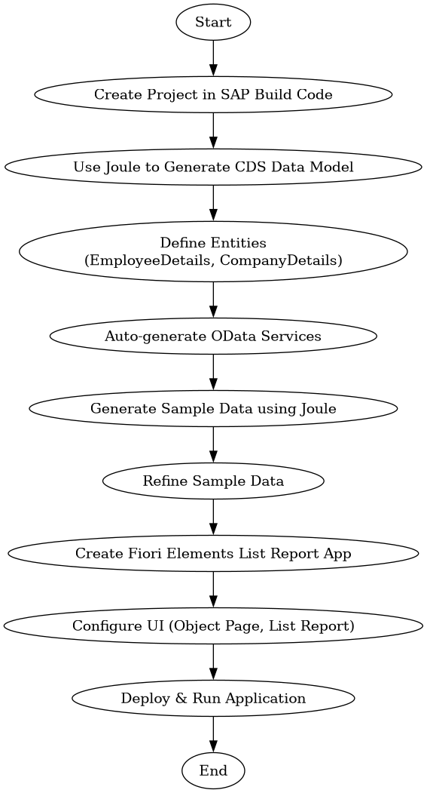

9.1 Process Flow

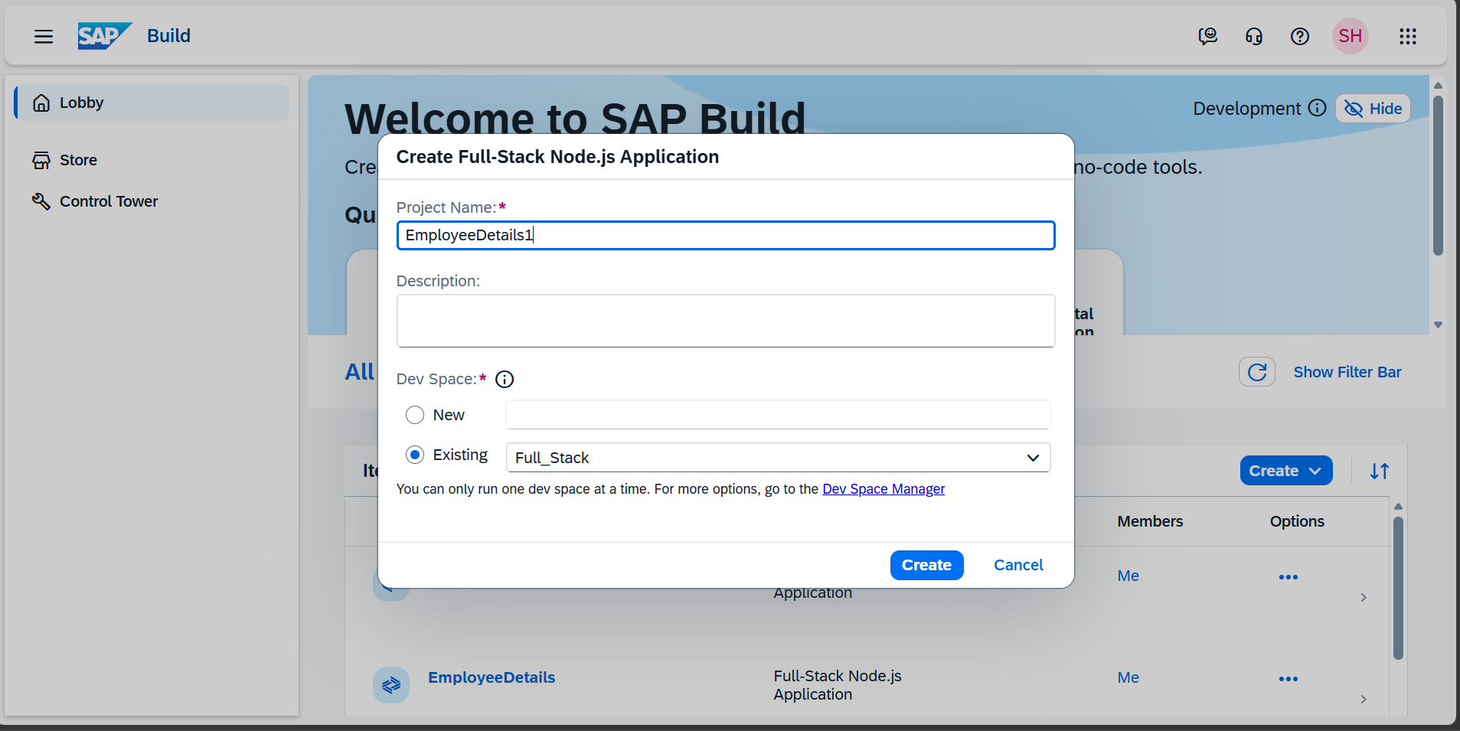
This step defines the initial configuration of a Full-Stack Node.js application by specifying the project name and selecting an appropriate development space.
It serves as the starting point for creating the application structure before proceeding with AI-assisted development using Joule.

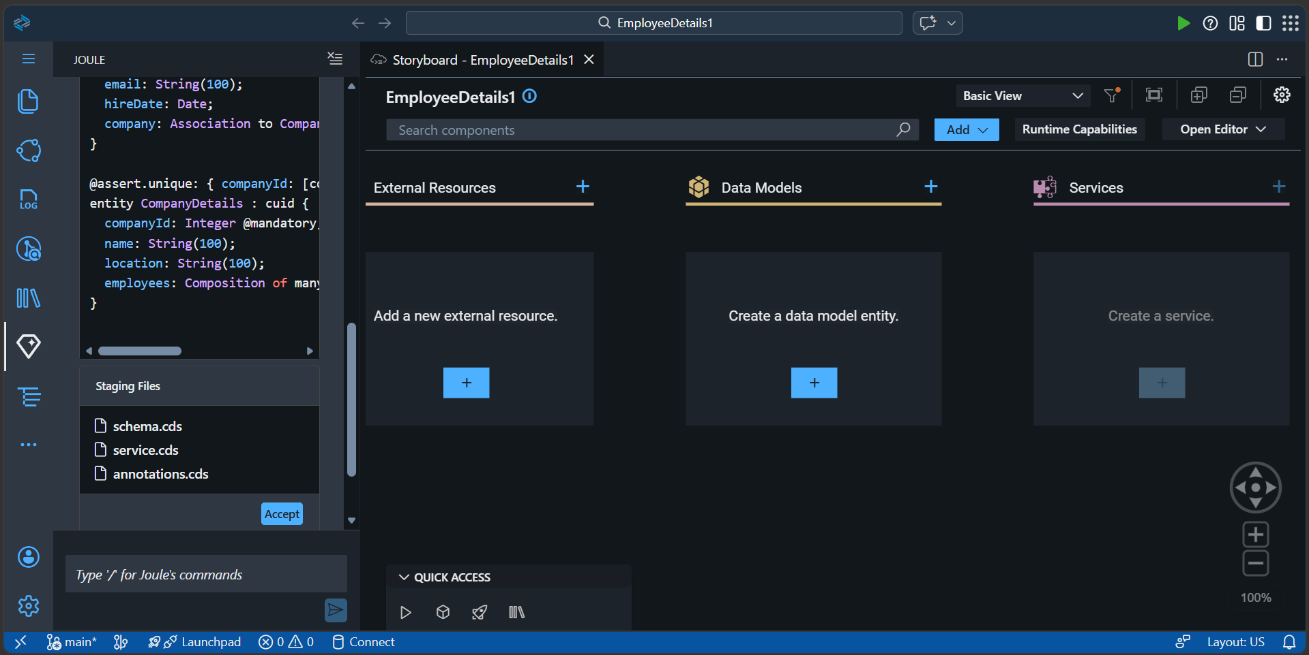
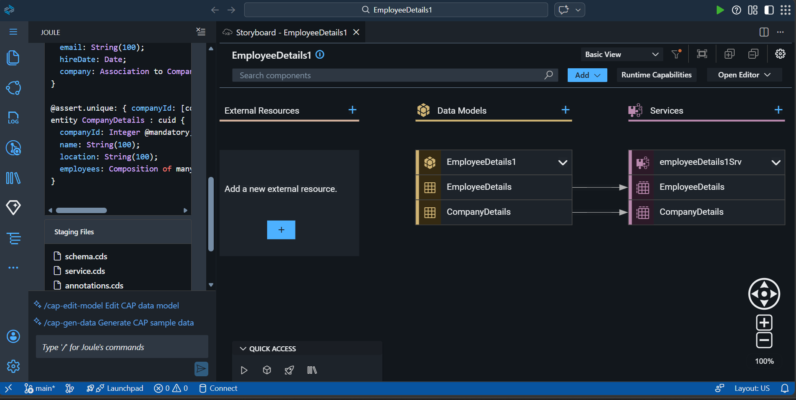
In the next step, Joule AI assists in generating and structuring the application components within SAP Build Code. Initially, the storyboard displays placeholders for data models and services along with AI-generated CDS artifacts. As development progresses, two entities—EmployeeDetails and CompanyDetails—are created and automatically linked to an OData service. This demonstrates a streamlined, AI-driven workflow where core components are visually connected with minimal manual intervention.
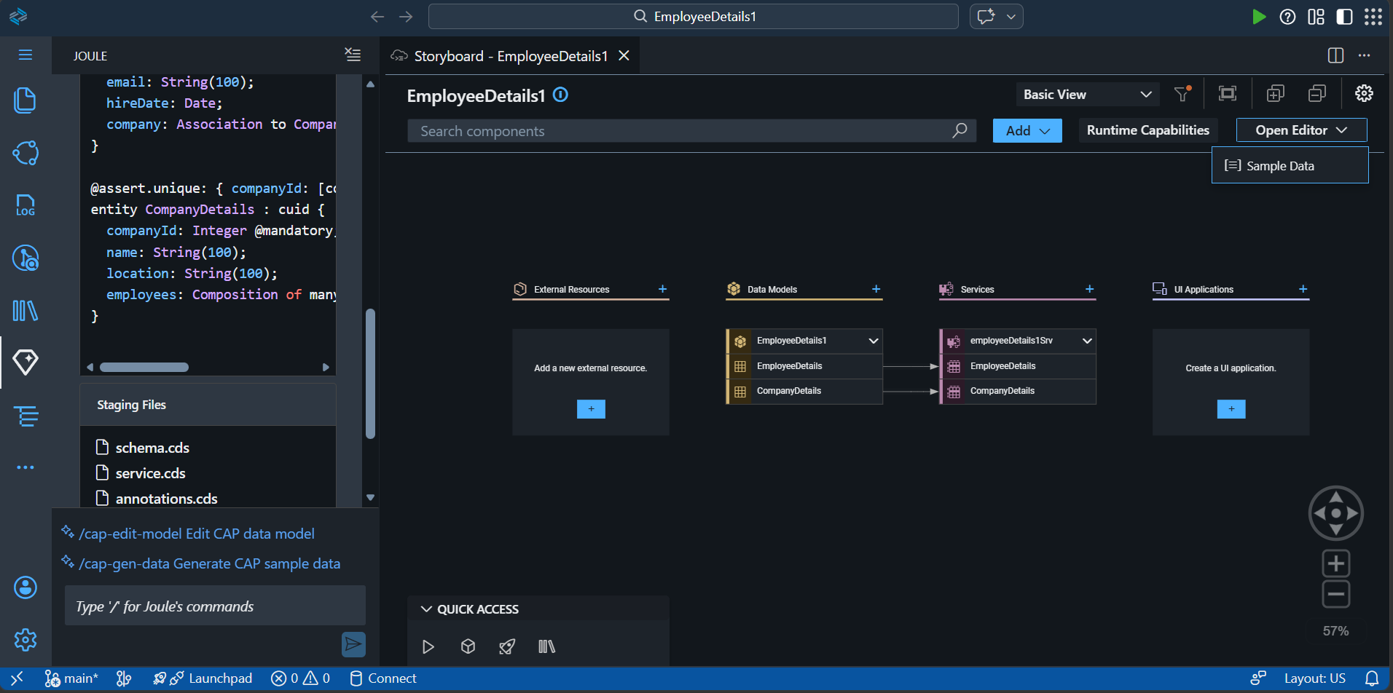
In the next step, sample data is generated using the Open Editor option, where Joule provides the capability to quickly populate the created data models with test data. By selecting Sample Data, the system automatically creates entries for the defined entities such as EmployeeDetails and CompanyDetails. This helps in validating the data model and enables immediate visualization of data within the application without manual data entry.
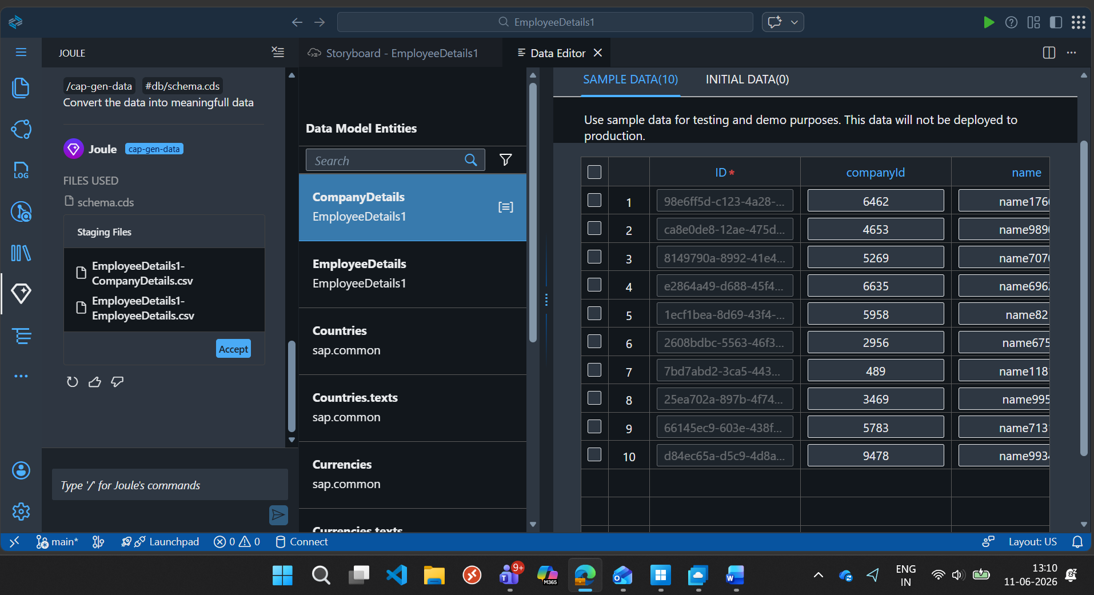
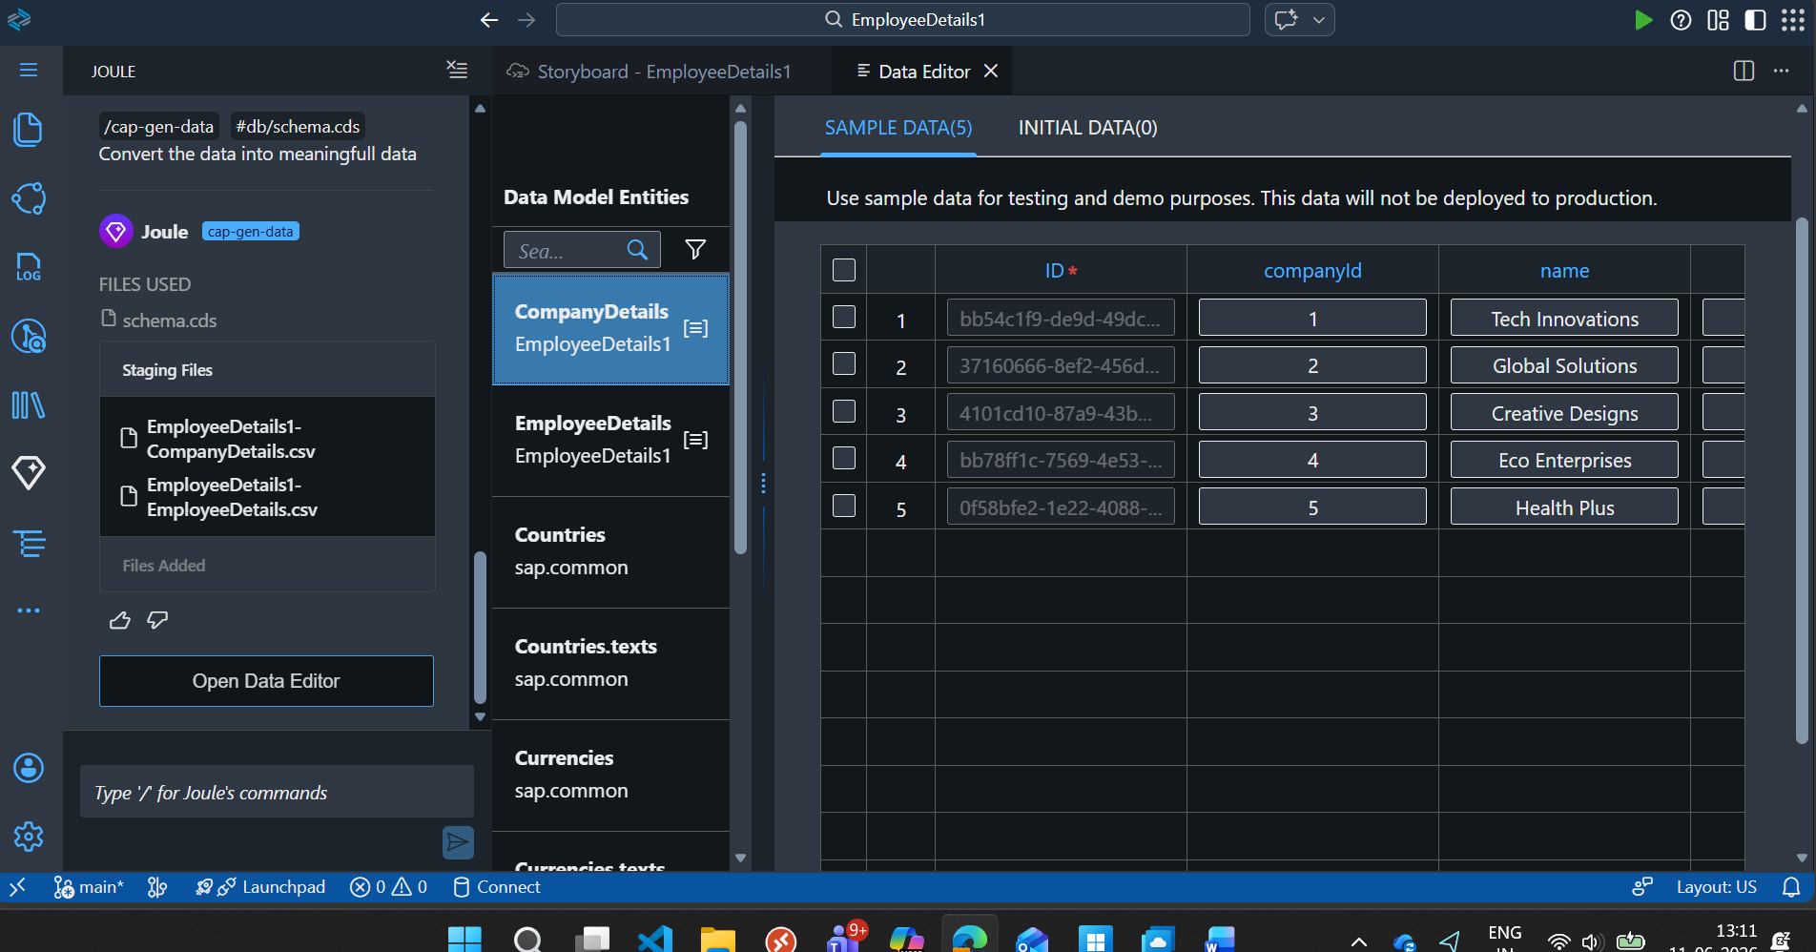
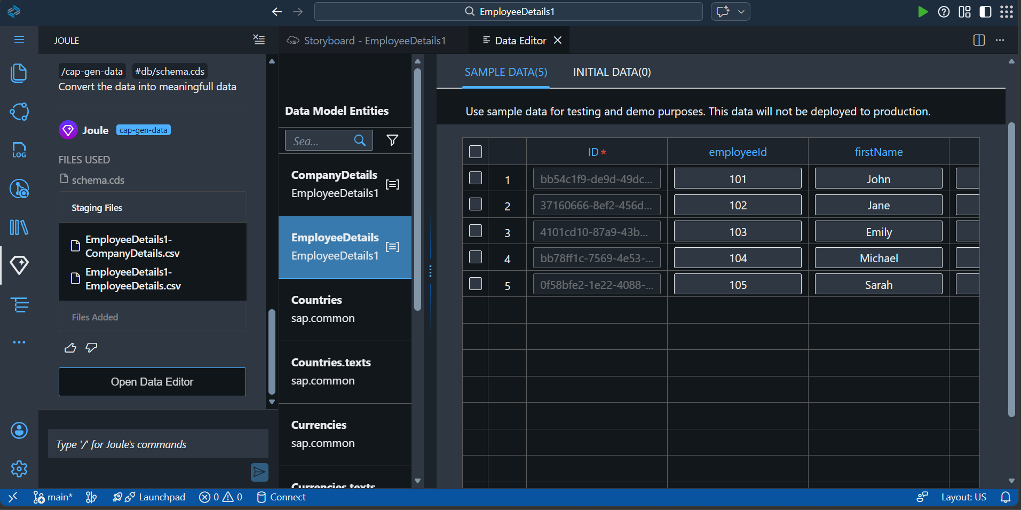
The Generated Data is converted into meaningful data using Joule.
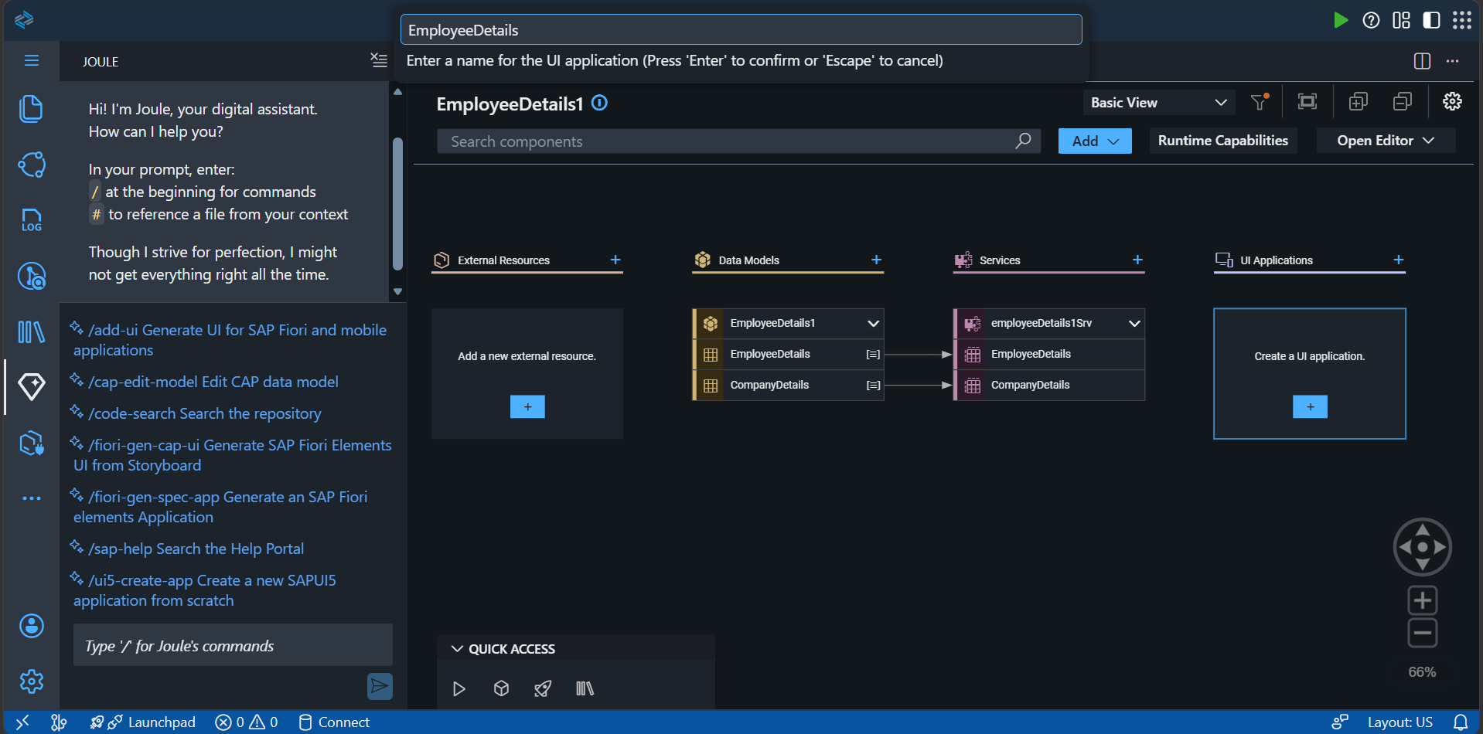
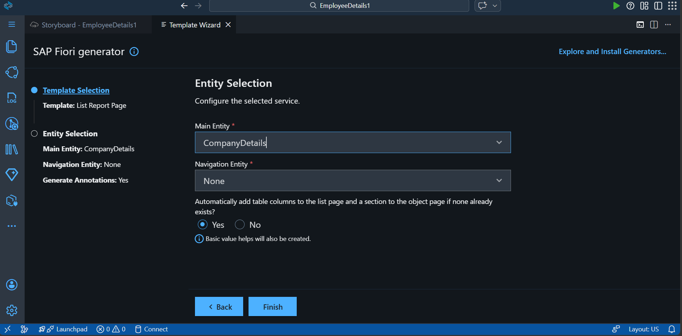
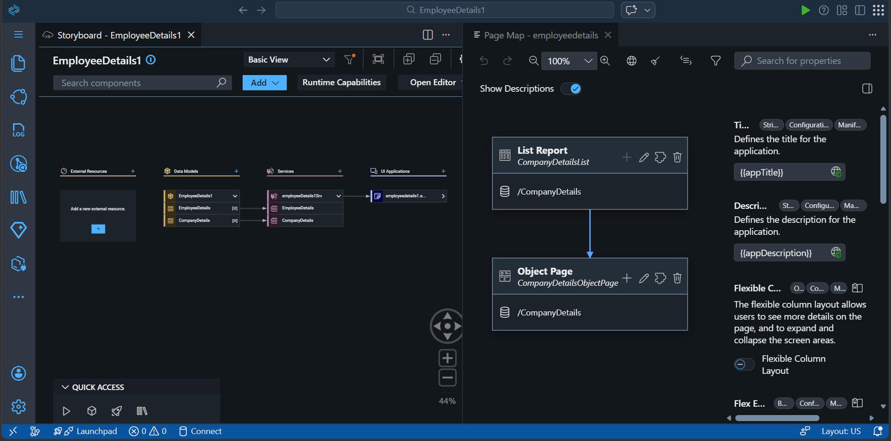
In the next step, an SAP Fiori Elements List Report application is created using the template wizard. The main entity (CompanyDetails) is selected, and Joule assists in configuring the application with minimal input. Once completed, the system automatically generates both the List Report and Object Page, providing a structured UI for displaying and managing the data. This demonstrates how UI applications can be quickly built using a metadata-driven and AI-assisted approach.

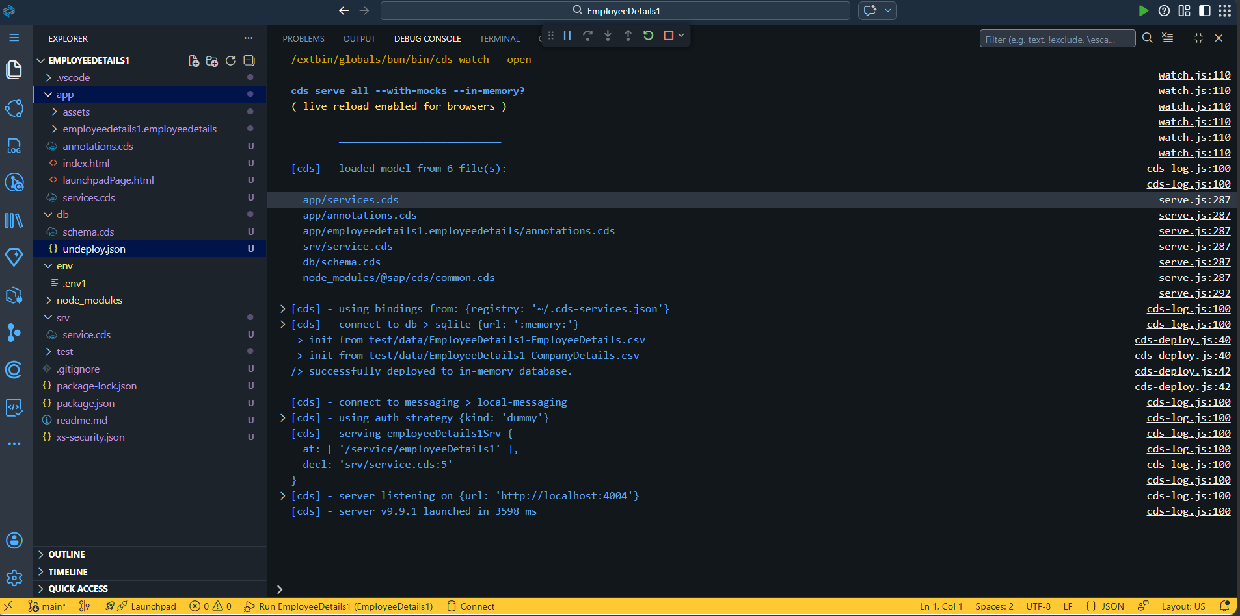

10 Output Files Generated by AI Assisted Application Development Using Joule 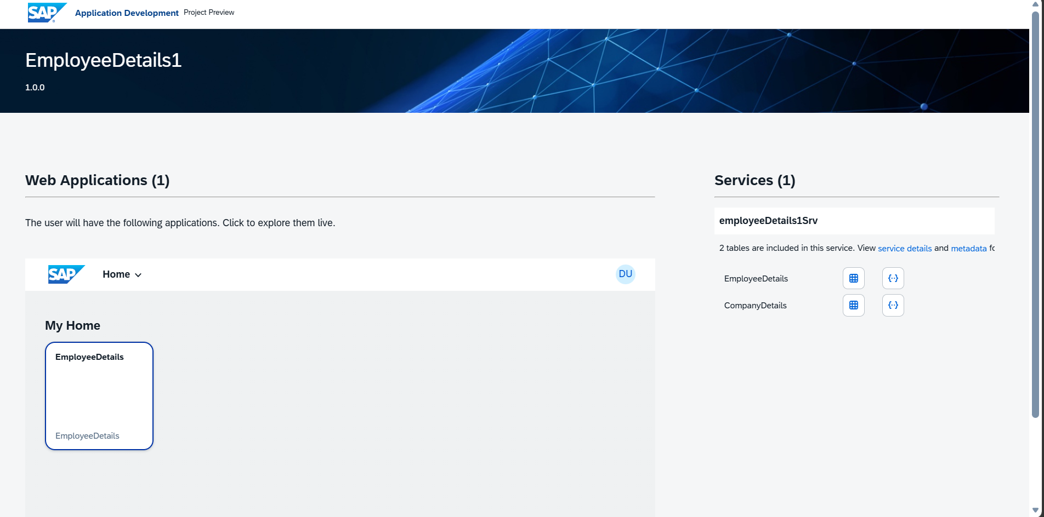

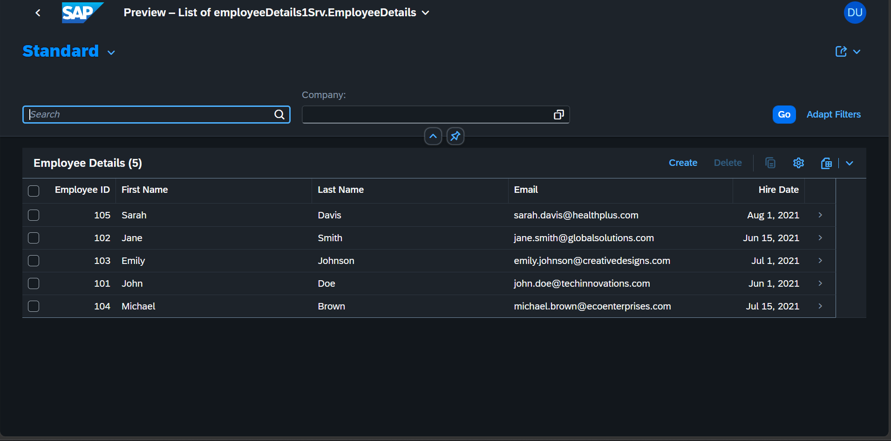
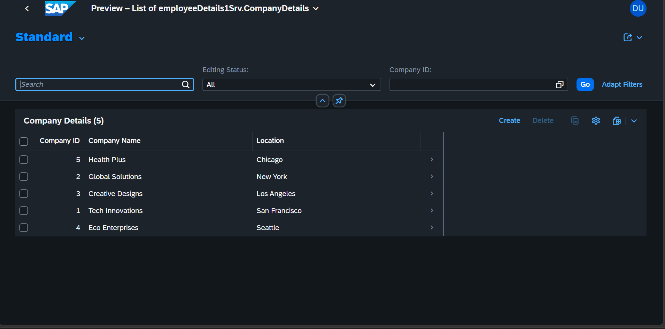

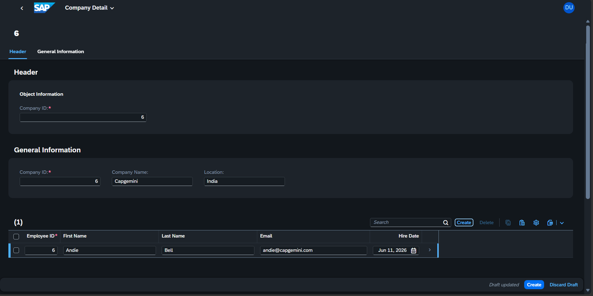
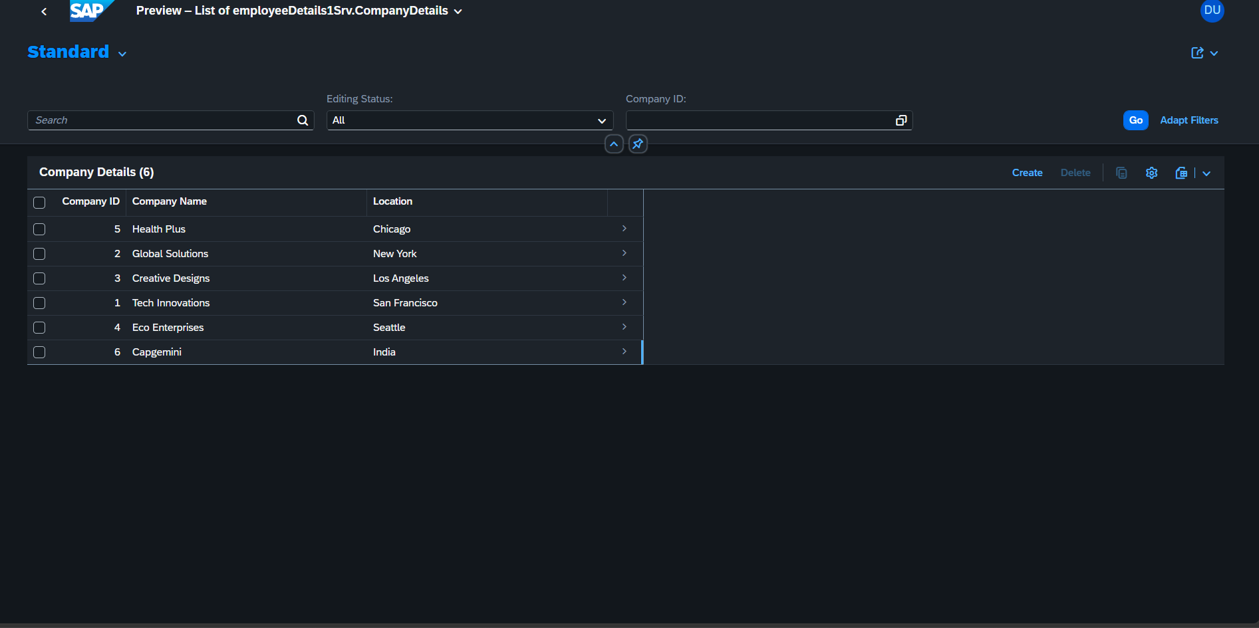
Above Images describes the generated SAP Fiori List Report interface created after performing the Create action, displaying structured data from CDS entities with built-in features like filtering, sorting, and table visualization.

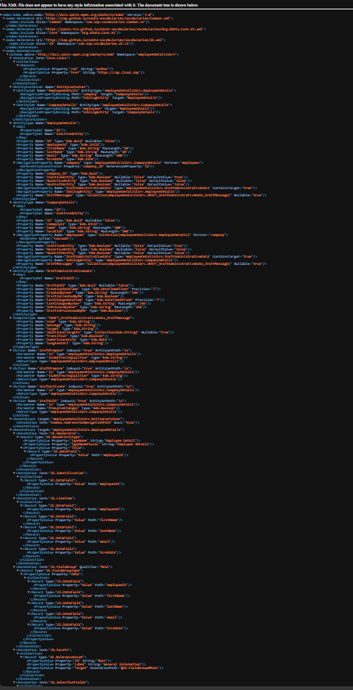
The generated metadata defines the structure, navigation, and UI behaviour, enabling a ready-to-use application with minimal manual configuration.

11. Conclusion
To summarize, this paper presents a practical example of how AI-assisted development using Joule in SAP Build Code can be leveraged to quickly create a simple data-driven application. The solution
demonstrates the creation of CDS-based data models and an SAP Fiori Elements List Report application through a metadata-driven approach, with minimal manual coding effort. It highlights how developers can rapidly build and visualize applications by generating core components such as data entities, services, and UI using natural language prompts, enabling efficient prototyping within the SAP ecosystem.

12. FAQ Link
NA

13. References
- Developing an Application Using Joule

- Build a CAPM & Fiori App in Minutes with Joule AI & SAP Build Code | SAP Gen AI Project

